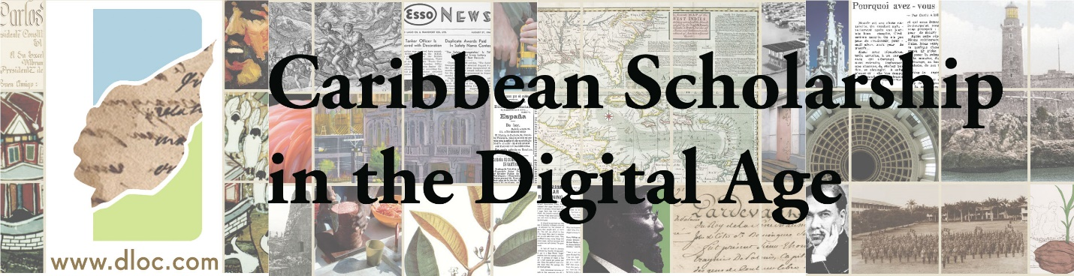

Caribbean Scholarship in the Digital Age is a webinar series showcasing digital and/as public research and teaching in Caribbean Studies. The series provides a collaborative space for professionals to share on projects and experiences to foster communication and support our shared constellations of communities of practice.

Please join us for an upcoming event featuring innovative digital work with Colony in Crisis, April 11, 2017, at 11am (Miami Time).

Presenter: Nathan Dize and Abby Broughton (Vanderbilt University)

Click here to participate in the online event: http://ufsmathers.adobeconnect.com/Caribbean

About the Presentation:
A digital project created in 2014 through the collaboration of two graduate students and a librarian, A Colony in Crisis (CiC, https://colonyincrisis.lib.umd.edu/) exemplifies interdisciplinary and interdepartmental research in the contemporary, media-enhanced age of humanities scholarship. Working through the framework of the grain crisis of 1789 in colonial Saint-Domingue, CiC provides English translations and introductions of original French pamphlets in hopes of promoting a glimpse into one of the many alternative histories of the Atlantic World in the years preceding the Haitian Revolution. With the goal of curating archival documents in order to offer students and scholars alike the possibility of working with archival texts across language barriers, the team partners with instructors to implement the project in the undergraduate classroom. Fall 2015 saw the implementation of CiC in an upper-level French literature course. One year later, the team reflects on their first foray into the classroom and where to steer the project over the years to come.

About the Speakers:
Abby R. Broughton is a PhD student in the Department of French and Italian at Vanderbilt University, where she specializes in 20th century queer literature, body and identity politics, and the intersection of illustration and text. Abby is a co-author, translator, and editor of A Colony in Crisis: The Saint-Domingue Grain Shortage of 1789.
Nathan H. Dize is a PhD student in the Department of French and Italian at Vanderbilt University where he specializes in Haitian theater, poetry, and revolutionary poetics during the nineteenth and early twentieth centuries. Nathan is the content curator, translator, and editor of A Colony in Crisis: The Saint-Domingue Grain Shortage of 1789.

About the Caribbean Scholarship in the Digital Age Webinar Series:
The Digital Library of the Caribbean (dLOC), in partnership with the Association of Caribbean University, Research and Institutional Libraries (ACURIL), the Graduate School of Information Sciences and Technologies of the University of Puerto Rico, the Latin American and Caribbean Cultural Heritage Archives roundtable (LACCHA) of the Society of American Archivists (SAA), and the Seminar on the Acquisition of Latin American Library Materials (SALALM), has organized a series of online events, Caribbean Scholarship in the Digital Age, a webinar series showcasing digital and/as public research and teaching in Caribbean Studies. The series provides a collaborative space for professionals to share on projects and experiences to foster communication and support our shared constellations of communities of practice.

Other upcoming webinars in the series include:
- May 10, 11am Miami time, Dr. Sara Gonzalez on 3D printing services
- Date pending for: Caribbean Memory
Recordings of all webinars will be available in dLOC soon after the webinar.

Please join us for next stage conversations from the webinars, to take place at ACURIL’s 2017 annual conference, focusing on Interdisciplinary Research in the Caribbean: http://acuril2017puertorico.com/

Twitter: #digcaribbeanscholarship

