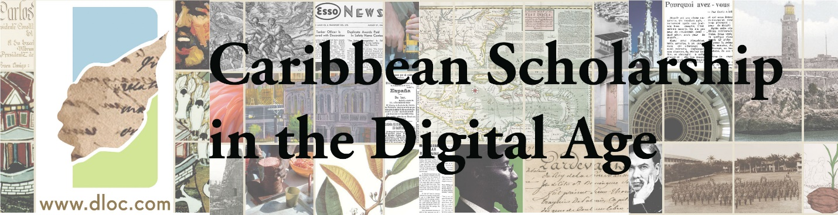

Caribbean Scholarship in the Digital Age is a webinar series showcasing digital and/as public research and teaching in Caribbean Studies. The series provides a collaborative space for professionals to share on projects and experiences to foster communication and support our shared constellations of communities of practice.

Please join us for an upcoming event featuring innovative digital work in Dominica on January 18, 2017, at 11am (Miami Time).

Presenter: Dr. Schuyler Esprit, Dominica State College, Create Caribbean Inc.

Click here to participate in the online event: http://ufsmathers.adobeconnect.com/Caribbean

About the Presentation:
In the small island developing state of the Commonwealth of Dominica, the push towards Information and Communications Technology (ICT) development has risen rapidly on the national agenda. This is true for several sectors, including entrepreneurship and education. However, national efforts to understand the impact of expanding technologies, particularly through the use of digital humanities or humanities computing, has been much slower despite collective enthusiasm among library and museum experts, academics and other intellectuals workers about developing the technological scope and reach of their work. For the most part, efforts and resources to encourage ICT use have minimized these very knowledge and culture nerve centers that inform the content of entrepreneurship through technology. Create Caribbean Inc. is a research institute located in Dominica, designed on the principles and values of digital scholarship and practicing digital humanities methodologies, and is one of the first of its kind in the English-speaking Caribbean to formalize the confluence of archival studies, heritage preservation, academic research, higher education curriculum development and the wave of technological advancement. Founded in 2014, the Institute has entered into a partnership with the Dominica State College to institutionalize and create national conversation and impact on innovative knowledge acquisition and sharing amidst economic and geographic constraints that create large social gaps in access to libraries, research, cultural activities and technological experimentation. This presentation will explore the best practices of Create Caribbean Inc., the Research Institute at Dominica State College to consider its goals and objectives, growth process, challenges and plans for enhancement and expansion beyond Dominica and into the wider Caribbean. The presentation will outline the role of each of the institute’s core areas – heritage preservation, academic research, higher education curriculum development, college teaching and community outreach – through the lens of the digital humanities and its impact on the Caribbean space. I will also include a discussion of the benefits of adopting digital humanities vocabulary, theory and praxis within the region, adapting those elements to considerations of economic, social and political peculiarities of the Caribbean.

About the Speaker: Dr. Schuyler Esprit is a scholar of Caribbean literature and cultural studies, and postcolonial theory. Dr. Esprit holds a PhD in English literature from University of Maryland – College Park. She is the Founding Director of Create Caribbean Inc. (http://createcaribbean.org/create/), Research Institute at Dominica State College. The Research Institute supports students and scholars to use digital technologies for research, teaching and learning in areas of Caribbean development, especially its culture, history and heritage. She currently works as Dean of Academic Affairs at Dominica State College. Dr. Esprit has also taught and held professional positions at a number of universities in the United States. She is now completing her book entitled West Indian Readers: A Social History and its digital companion, both of which are historical explorations of reading culture in the Caribbean. She has also written the introduction to the 2016 Papillote Press edition of The Orchid House, the 1953 novel by Dominican writer Phyllis Shand Allfrey.

About the Caribbean Scholarship in the Digital Age Webinar Series:
The Digital Library of the Caribbean (dLOC), in partnership with the Association of Caribbean University, Research and Institutional Libraries (ACURIL), the Graduate School of Information Sciences and Technologies of the University of Puerto Rico, and the Latin American and Caribbean Cultural Heritage Archives roundtable (LACCHA) of the Society of American Archivists (SAA), has organized a series of online events, Caribbean Scholarship in the Digital Age, a webinar series showcasing digital and/as public research and teaching in Caribbean Studies. The series provides a collaborative space for professionals to share on projects and experiences to foster communication and support our shared constellations of communities of practice.

Other upcoming webinars in the series include:
- Feb. 28, 11am Miami time: Dr. Alex Gil on small axe: archipelagos
- Apr. 11, 11am Miami time: Nathan Dize and Abby Broughton on Colony in Crisis
- May 10, 11am Miami time, Dr. Sara Gonzalez on 3D printing services
- Date pending for: Caribbean Memory
Recordings of all webinars will be available in dLOC soon after the webinar.

Please join us for next stage conversations from the webinars, to take place at ACURIL’s 2017 annual conference, focusing on Interdisciplinary Research in the Caribbean: http://acuril2017puertorico.com/

Twitter: @dlocaribbean

